MANUAL RBC’s COUNT

INTRODUCTION :
-some information that we have already studied in physiology about the red blood cells ( Erythrocytes ) :
*they are biconcave in shape .
*have no nucleus .
*they contain red pigments called hemoglobin which is responsible for the red color of the blood .
*they live for 120 days .
** a healthy male has about 4.5 – 6 million of RBCs per cubic millimeter ( mm3 )
And a healthy female about 4 – 5.5 million .

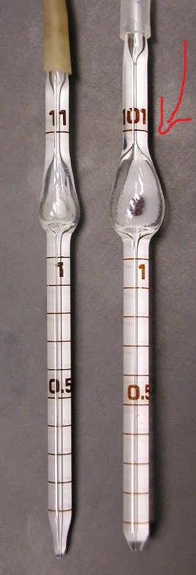
- IN THIS LAB :
we want to determine the number of RBCs in a cubic millimeter of blood
*BUT because the number of RBCs is very large we will dilute( ( نخفف the sample of the blood .
* for the dilution we will use isotonic solution like ( Hayem’s solution ) .
Note :
in the exam he can mention the dilute solution in three ways and they all give the same meaning ..
* ISOTONIC SOLUTION –* HAYEM’S SOLUTION –* NORMAL SALINE

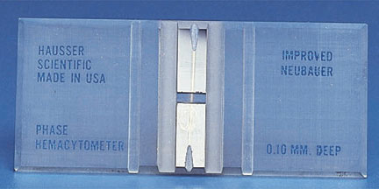
- HOW WE COUT :
a) THE MATERIALS we will need :
Fig. 1
- Blood sample.
- RBCs diluting pipette ( fig. 1 ) .
- diluting fluid ( as we mention we will use Hayem’s solution ) .
Fig. 2
- hemocytometer (fig. 2 ).
-and of course a microscope

+ the RBCs diluting pipette :
*it’s a special pipette consists of stem and bulb and usually have red bead .
* the whole volume of the pipette is 101 unit volume .
Notice that WBCs diluting pipette is smaller than the RBCs one.. Its whole volume 11 unit volume
also another different is that the WBCs pipette have white bead ( look at the fig. 1 )
+ the hemacytometer :
* the hemacytometer chamber is used for counting the cells ( as in the fig. bellow ) 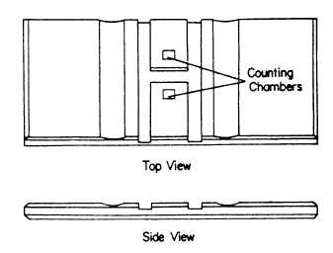
* the surface of the chamber contains TWO IDENTICAL squares and they are separated by an H – shaped moat (زي الخندق )
* because these two squares are identical they allow technologist to duplicate the cell count .
* each square has a total area of 9 mm2 ( مساحته ) 3 x 3 .
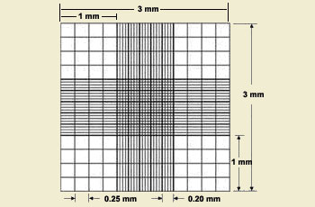
*these sqares are divided into nine primary squares with an an area of 1 mm2 .

Note:
we will just use the central primary square for RBCs count .
it consists of 25 secondary squares and each one of these 25 squares is divided into 16 smaller squares
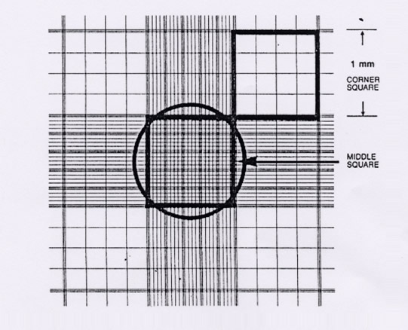

- PROCEDURES:
1- put the blood in the RBCs pipette up to 0.5 mark .
Note:
- it’s not necessary to put 0.5 of blood we can put blood up to 1 unit volume.
So in the exam he may mention another number instead of 0.5 BUT if he doesn’t mention any number then assume that the number is 0.5.
- We use EDTA as an anticoagulant for blood ( مسيل للدم ) .

2- let the blood reach to pipette .
3- put the hayems solution in the pipette up to 101
Note :
- the volume of the pipette is 101 BUT the volume of the blood that we will count is 100 because we let the blood with the haymes solution to fill the bulb of the pipette and there’s nothing in the stem .

4- mix for 2-3 min.
5- now we will fill the hemacytometer :
*dicard the first 4-5 drops
* place the tip of the pipette at the edge of the central platform of hemacytometer slide and let a drop of diluted blood run between the hemacytometer slide and cover slip by capillarity ( الخاصية الشعرية ) ( fig. 3 )

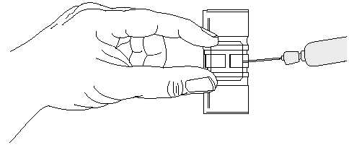
Fig. 3

6- let the hemacytomater to stand on the bench for 3 -5 min. SO the cells are settled down
Note :
-the distance between the cover slip and the surface of the counting area of the chamber is 0.1 mm . 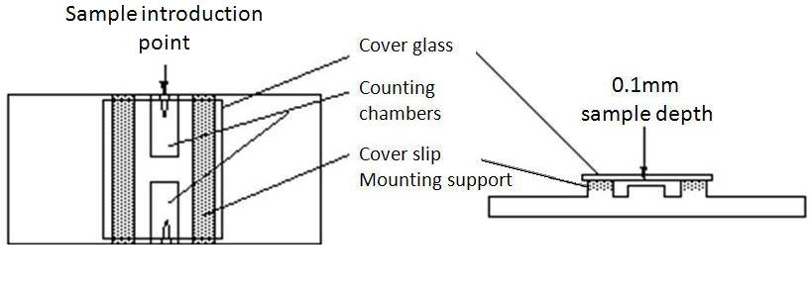
-JUST understand these procedures that I mentioned وما تحكولي صعب :P

- COUNT and CALCULATION:
A- * Under the microscope first we use 40 x magnification to see the 9 squares and then determine the central square
* from that square we only need the the 4 corner square and the central one and to determine these 5 squares we will use 100 x magnification ( fig.4 )
* to see each one of these 5 squares alone we will use 400x magnification
* we count all cells that touch the upper and left line AND don’t count any cells that touches a lower or right line ( for example look at fig. 5 )
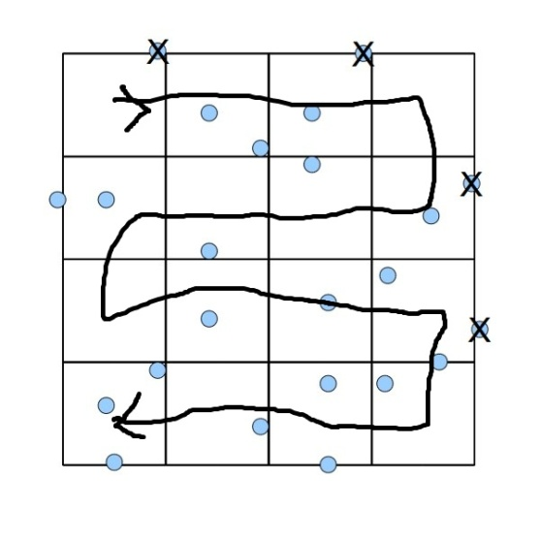
* نعد بطريقة " الزقزاق "
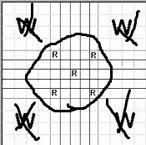
Fig. 5
Fig. 4

B- CALCULATION:
The method that I will mention is different from the book BUT its easier and its from the teacher so don’t worry
** the low : number of RBCs = ΣR1 and R2 X D.C.F X V.C.F
( or any two R )

D.C.F ( dilution correction factor ) = = = 200
V.C.F ( volume correction factor ) = 5 تعبر عن الخمس مربعات ) )
volume of R ( the volume of the small square ) = الطول x العرض x الارتفاع = 0.2 x 0.2 x 0.1 = 0.004 MM3
Note: the Height is for the coverslip ( ارتفاع الغطاء )
V.C.F = = 50
For example : #RBCs =ΣR1 and R2 X D.C.F X V.C.F
= 500 x 200 x 50 = 500.000
** I tried my best to make this clear if u don’t understand it u have to see the book
* IF the number of RBCs is lower than normal then we have anemia
* if the number of RBCs is higher than normal then we have polycethemia
** polycethemia is 2 types :
1- primary polycethemia : RBCs over 14 million cells per mm3
- Occure in bone marrow malignancy
2- secondary : polycethemia : RBCs is 8 million cells per mm3
- its caused by : *respiratory disease
* heart disease
* chronic carbon dioxide poisoning

بذلت ما في وسعي لتبسيط الكتاب وادراج كل ما ذكره الدكتور في شرحه .. سامحوني على تقصيري وارجو من كل قلبي ان تستفيدوا ^^

DONE BY : HARETH INAYA
EDITED BY : Hazem Mohamed

