Practice questions for First Biostatistics Exam – E learning.

In January of 2006, a family moved to a tropical (rainy) climate. For the year that followed, they recorded the number of rainy days that occurred each month. The sample measurements contained: 14, 14, 10, 12, 11, 13, 11, 11, 14, 10, 13, 8 rainy days per month.
Calculate the mean, mode, median

The below numbers represent ages (in years) for 13 students. Calculate the mean
21, 22, 24, 21, 22, 22, 22, 22, 23, 23, 23, 23 , 23

The below numbers represent ages (in years) for 13 students. Calculate the median
21, 22, 24, 21, 22, 22, 22, 22, 23, 23, 23, 23 , 23

Median –

The below numbers represent ages (in years) for 13 students. Calculate the mode
21, 22, 24, 21, 22, 22, 22, 22, 23, 23, 23, 23 , 23

If the variance of a population is 9, the population standard deviation is:

3
9
21.3
81

Which of the following is not a measure of dispersion?

Percentile
Quartile
Standard deviation
Mode

The term test scores of 15 students enrolled in a Biostatistics class were recorded in ascending order as follows:
4, 7, 7, 9, 10, 11, 13, 15, 15, 15, 17, 17, 19, 19, 20

After calculating the mean, median, and mode, an error is discovered: one of the 15’s is really a 17. The measures of central tendency which will change are:

The mean only
The mode only
The median only
The mean and mode
All three measures

<Q> The joint probability of events A and B is 30%, the probability of event A is 60% and the probability of event B being 50%. Based on this information, the probability of A or B is:

<C> 80.0%.
<C> 50.%.
<C> 60.0%.
<C> 80

Which of the following is a binary variable?
- number of cars
- height
- weight
- smoking status

What is a nominal scale?

What is an ordinal scale?
What is an interval scale?
What is quantitative data? What is qualitative data?

What is a binary value?

What measure do we use to compare variability in two populations?

What are descriptive statistics?

What type of data representation is the below?

What does it tell you?

Which year had a larger number of female cases 1999 or 1996?

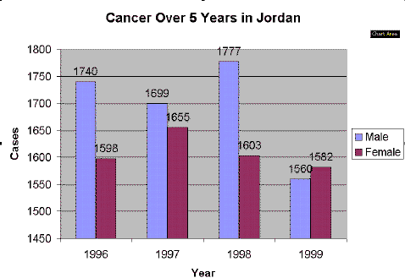

Look at the box and whisker plots below for exam results in Algebra.

Which class has a higher median score? Class 1
Which class has the largest range of values? Class 2
What is this range? 50%
Which class has the smaller interquartile range?

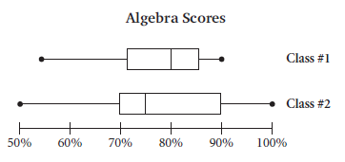

Interpret the pie chart below.

- There are four different chocolates in a bowl, one is a mars bar. What is the probability that you will pick a mars bar?

¼

- There are four chocolates in a bowl, two are mars bars, one is snickers and one is bounty. What is the probability that you will pick a mars bar?
2/4

- You have the same bowel as above. What is the probability that you pick a mars bar both on the first and the second pick?

P(mars 1st pick) + P (mars 2nd pick) = 2/4 x 1/3 = 2/12 = 1/6

- P(at least one tail) out of 3 flips

= P(of not getting all head) = 1- P(HHH)
1-1/8

What is Marginal Probability

What is the complement of an event?

What is conditional probability?

Given an example.

