WBC's count

# Introduction
White blood cell count : is the count of total number of leukocytes in a volume of blood, expressed as WBC's/1 mm³ blood .
# WBC's or leukocytes are :
1- colorless *
2- nucleated cells
# They are formed from stem cells in the bone marrow
** Function : they protect the body tissues by engulfing disease-bearing bacteria and foreign matter , by a process called phagocytosis .

#principle of the text :
# Because the number of WBC's in a cubic millimeter of blood is large , it is practical a sample of blood with a diluting solution “ 2% Glacial acetic acid with methylene blue “

** We use a Glacial acetic acid to lysis all cytoplasmic membrane , therefore leaving the nuclei of WBC's .
**Nucli of WBC's are colorless so for watch them under microscope we use a dye called methylene blue
** 2% >> the percentage of diluting
#Experience tools
1] blood sample
2] WBC's diluting pipette
3] hemocytometer
4] diluting fluid ( 2% acetic acid & methylene blue
5] microscope

# WBC's diluting pipette :
WBC's pipette is special pipette consist of stem and blub , it have three marks ( 0.5 ; 1.0 & 11 ) and usually have a white bead .
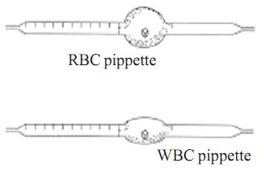
#The hemacytometer :
** the hemacytometer counting chamber is used for cell counting .
** the distance between the bottom of the cover slip and the surface of the counting area of the chamber is 0.1 mm ( 1/10 mm )
** the surface of the chamber contains two square ruled areas separated by an H-shaped moat , these two square are identical , allowing the technologist to duplicate the cell count .
** Each has a total area of 9 mm² these squares are dividing into nine primary* squares with an area of 1 mm² each .
** The four corner primary squares are used when counting leukocytes , each of them contain 16 secondary ( medium ) squares.
** The central primary squar is used for RBC's count , it consist of 25 secondary (medium) squares , and each of these 25 squares is further divided into 16 smaller tertiary (smallest ) squares .
# specimen ( EDTA-anticoagulated blood or capillary blood is preferred .)

#procedure :
1] with a safety bulb draw blood up to 0.5 marks on WBC's pipette snd complete to 11 with WBC's diluting solution
2] mix for 2-3 minute
3] charge hemacytometer
Load the counting chamber with diluting blood as follows :
** discard the first 4-5 drop
**place tip of pipette at edge of the central platform of hemacytometer slide and let a drop of diluted blood run between the hemacytometer slide and cover slip by capillarity
4] let the hemacytometer to stand on the bench for 3-5 minute so the celle are settled down

#count & calculate :
** place the hemacytometer on the microscope stage and focus with the 4X objective , on the ruled area , move to the 10X and focus on one of the large corner square .
** counting :
Count the cells in each large squares starting from the upper left medium square and follows the pattern indicated by the arrow in following square .
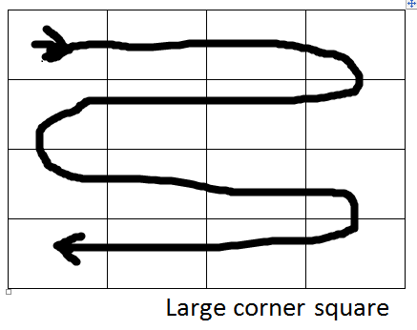
Count the cells within each square including cells touching the line at the top and on the left . cells touching the line on the right and at the bottom should not be counted **.
Get the total number of cells counted in all four large squares .
# calculation :
Number of cells/cubic mm blood = counted cell in 4 large square * dilution factor * volume correction factor
Dilution factor = 20
Volume correction factor = 2.5
شوفوا ال calculation من المانيوال ص 10 :P
ال dilution w volume correction factor ثابتات بس احفظوا ال calculation احتياط اذا طلب شي عنهم :3

Normal values :
Newborn 9000-30000 cell/cu mm blood
Adult 4000-11000 cell/cu mm blood

** Significance of the test :
There are two important definition related to the leckocytes :
1-leukocytosis: a condition when total number of WBC's exceeds normal WBC's count ( 11000 cells/ mm³ ) and occur as an indicator of body defense against foreign materials ( bacteria , parasites & toxins ) .

2- leucopenia : a condition when the total number of WBC's below normal ( 4800 cells/mm³ ) and result from x-ray therapy , Alcoholism , Antibiotic therapy , typhoid infection , measles , infectious hepatitis , tuberculosis , and cirrhosis of the liver .

#sources of error :
1] flooding of chamber with excess sample
2] failing to count all the cells in the square or conversely including artifacts the count .

DONE BY : Sarah faisal ^^
EDITED BY : Hazem Mohamed ^^

